MINI PROJECT REPORT
Attendance Management System

A Web-Based Application for Digital Student Attendance Tracking

Name: Neel Dube
Enrollment No.: 240503020016
Subject: PHP
Stream: BCA Cybersecurity
Class: A1

*Web Development using PHP

Certificate
This is to certify that Neel Dube (Enrollment No. 240503020016), a student of BCA Cybersecurity, Class A1, has successfully completed the mini project titled “Attendance Management System” under the subject Python, as part of the Active Learning Activity prescribed by the department.
The project was carried out under the guidance and approval of the concerned faculty and is submitted in partial fulfilment of the course requirements.

Faculty Signature: ______________________
Date: ______________________

Declaration
I, Neel Dube, hereby declare that the mini project titled “Attendance Management System” is an original piece of work carried out by me under the Python subject for BCA Cybersecurity, Class A1. The design, code, and documentation presented in this report are my own work, developed for academic purposes, and have not been submitted elsewhere for any other course or qualification.

Name: Neel Dube
Enrollment No.: 240503020016
Signature: ______________________

Acknowledgement
I would like to express my sincere gratitude to my faculty guide for the valuable guidance, feedback, and encouragement provided throughout the development of this mini project. Their support in reviewing the problem statement and approving the project scope was instrumental in shaping the final outcome.
I would also like to thank the Department of BCA Cybersecurity for providing the opportunity to work on this Active Learning Activity, and my peers for their helpful discussions during the design and testing phases of this project.

Abstract
Manual, paper-based attendance registers are slow to fill in, easy to misplace, and painful to summarize at the end of a term. The Attendance Management System addresses this by giving teachers and administrators a simple web application to register students, mark daily attendance, and instantly view attendance percentages — replacing registers and spreadsheets with a single, always-up-to-date source of truth. The system is implemented using PHP for server-side logic and MySQL for persistent storage, following the classic LAMP-style web architecture. It supports four core features: adding students, marking date-wise attendance, generating attendance reports, and automatically calculating attendance percentage per student, with students below a 75% threshold flagged for follow-up. This report documents the problem being solved, the system's design (including its entity-relationship model), its implementation with representative code, its user interface with screenshots, and the testing carried out before deployment.

Table of Contents
▸ 1. Introduction
▸ 2. Objectives
▸ 3. System Requirements
▸ 4. Feasibility Study
▸ 5. System Design
▸ 5.1 Entity-Relationship Diagram
▸ 5.2 Database Schema
▸ 5.3 Data Flow / Process Overview
▸ 6. Module Description
▸ 7. Implementation
▸ 8. Screenshots
▸ 9. Testing
▸ 10. Future Scope
▸ 11. Conclusion
▸ 12. References

1. Introduction
Tracking attendance is a routine but essential task in any academic institution — it feeds into eligibility for exams, scholarships, and disciplinary decisions. Traditional paper registers require a teacher to manually tally presence for every student, every day, and manually recompute totals whenever attendance is queried, which is both time-consuming and error-prone. As class sizes grow, this manual process scales poorly and increases the chance of transcription errors.
The Attendance Management System is a mini web application that digitizes this entire workflow. It allows an administrator or teacher to register students once, then mark each student Present or Absent for any given date through a simple web form. Behind the scenes, a MySQL database stores every attendance record, and the application computes attendance percentages on demand — removing the need for any manual calculation. The result is a lightweight, self-contained system that can be deployed on any standard PHP/MySQL hosting environment, including a local XAMPP or WAMP setup for demonstration purposes.

2. Objectives
▸ Provide a simple interface to add and maintain a list of enrolled students.
▸ Allow attendance to be marked quickly for any date, for all students at once.
▸ Store every attendance record reliably, preventing duplicate entries for the same student and date.
▸ Automatically generate a report showing each student's total classes, days present, and attendance percentage.
▸ Flag students whose attendance falls below the standard 75% eligibility threshold.
▸ Keep the system lightweight enough to run on any basic PHP/MySQL hosting setup, with no external dependencies.

3. System Requirements

3.1 Hardware Requirements
Component | Minimum Specification
Processor | Dual-core 1.6 GHz or higher
RAM | 2 GB or higher
Storage | 100 MB free disk space
Display | Any screen supporting a modern web browser

3.2 Software Requirements
Component | Technology Used
Server-side Language | PHP 8.x
Database | MySQL 8.x (via phpMyAdmin)
Local Server Stack | XAMPP / WAMP (Apache + MySQL + PHP)
Frontend | HTML5, CSS3 (custom stylesheet)
Browser | Any modern browser — Chrome, Firefox, Edge

4. Feasibility Study

4.1 Technical Feasibility
The system uses only widely available, free, open-source technologies — PHP and MySQL — that run on virtually any hosting environment, including a student's own laptop via XAMPP. No specialized hardware or paid software is required, making the project fully feasible within a typical mini-project timeline.

4.2 Economic Feasibility
All tools used (PHP, MySQL, XAMPP, a code editor) are free and open-source, so the project has effectively zero licensing cost. The only ongoing cost in a real deployment would be standard web hosting, which is inexpensive for an application of this scale.

4.3 Operational Feasibility
The interface is intentionally simple — forms, dropdowns, and tables — so that a non-technical teacher or administrator can use it after a five-minute walkthrough, with no training manual required.

5. System Design

5.1 Entity-Relationship Diagram
The system's data model centers on two entities: students and attendance. Each student can have many attendance records (one per date), which is modeled as a one-to-many relationship, enforced in the database using a foreign key from attendance.student_id to students.student_id.
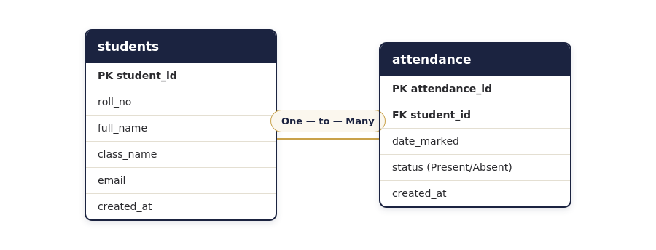
Figure 5.1 — Entity-Relationship Diagram (students → attendance)

5.2 Database Schema
The two tables are created with the following structure. A UNIQUE constraint on (student_id, date_marked) in the attendance table guarantees that a student cannot be marked twice for the same date; re-submitting the form for that date updates the existing row instead.
CREATE TABLE students (
student_id INT AUTO_INCREMENT PRIMARY KEY,
roll_no VARCHAR(20) NOT NULL UNIQUE,
full_name VARCHAR(100) NOT NULL,
class_name VARCHAR(50) NOT NULL,
email VARCHAR(100),
created_at TIMESTAMP DEFAULT CURRENT_TIMESTAMP
);

CREATE TABLE attendance (
attendance_id INT AUTO_INCREMENT PRIMARY KEY,
student_id INT NOT NULL,
date_marked DATE NOT NULL,
status ENUM('Present','Absent') NOT NULL,
created_at TIMESTAMP DEFAULT CURRENT_TIMESTAMP,
FOREIGN KEY (student_id) REFERENCES students(student_id),
UNIQUE KEY unique_attendance (student_id, date_marked)
);

5.3 Data Flow / Process Overview
▸ Admin opens the Add Student page and submits the registration form → a new row is inserted into students.
▸ Admin opens Mark Attendance, selects a date → the system lists all students with a Present/Absent dropdown.
▸ On submission, one row per student is inserted (or updated, if already marked) into attendance for that date.
▸ Admin opens Attendance Report → the system aggregates attendance per student and computes the percentage on the fly.

6. Module Description

6.1 Add Student Module
Captures a student's roll number, name, class, and optional email through a form, validates required fields, and inserts the record into the students table using a prepared statement to prevent SQL injection. The same page lists all currently registered students below the form.

6.2 Mark Attendance Module
Displays every registered student alongside a Present/Absent dropdown for a chosen date. On submission, the module either inserts a new attendance row or updates the existing one for that student and date, using MySQL's ON DUPLICATE KEY UPDATE clause — so re-marking a date never creates duplicate records.

6.3 Generate Attendance Report Module
Runs an aggregate SQL query that joins students with attendance, grouping by student to compute the total number of days marked and the number of days present for each student, displayed as a sortable table.

6.4 Calculate Attendance Percentage Module
Within the same report query, attendance percentage is computed directly in SQL as (days present ÷ days marked) × 100, rounded to one decimal place. Percentages below 75% are visually flagged in red using a conditional CSS class, so at-risk students are immediately visible without manually scanning the table.

7. Implementation
The application follows a simple procedural PHP structure: each page connects to the database via a shared db_connect.php include, runs the SQL needed for that page, and renders HTML using a shared header/footer for consistent navigation and styling. Below are representative snippets from two of the four core modules.

7.1 Mark Attendance — Saving Records (excerpt)
if ($_SERVER['REQUEST_METHOD'] === 'POST' && isset($_POST['submit_attendance'])) {
$date = $_POST['date_marked'];
$statuses = $_POST['status']; // [student_id => 'Present'/'Absent']

$stmt = $conn->prepare("
INSERT INTO attendance (student_id, date_marked, status)
VALUES (?, ?, ?)
ON DUPLICATE KEY UPDATE status = VALUES(status)
");

foreach ($statuses as $studentId => $status) {
$stmt->bind_param("iss", $studentId, $date, $status);
$stmt->execute();
}
}

7.2 Attendance Report — Percentage Calculation (excerpt)
SELECT
s.roll_no, s.full_name, s.class_name,
COUNT(a.attendance_id) AS total_marked,
SUM(a.status = 'Present') AS total_present,
ROUND(
IFNULL(SUM(a.status='Present') / NULLIF(COUNT(a.attendance_id),0) * 100, 0), 1
) AS attendance_pct
FROM students s
LEFT JOIN attendance a ON a.student_id = s.student_id
GROUP BY s.student_id
ORDER BY s.roll_no;

8. Screenshots
The following screenshots were captured from the running application (using representative sample data) and illustrate each of the four core modules.

8.1 Dashboard
The landing page shows live totals for registered students, today's present/absent counts, and the overall attendance percentage, with quick-action buttons to jump into the other modules.
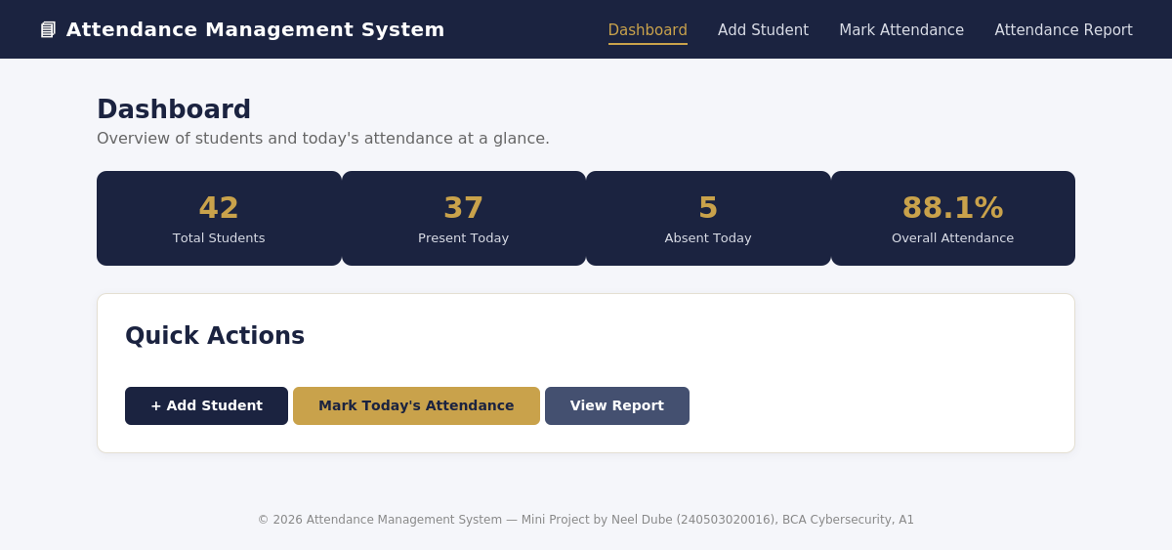
Figure 8.1 — Dashboard with summary statistics

8.2 Add Student
A simple form registers a new student; the table below the form lists every student currently in the system for quick verification.
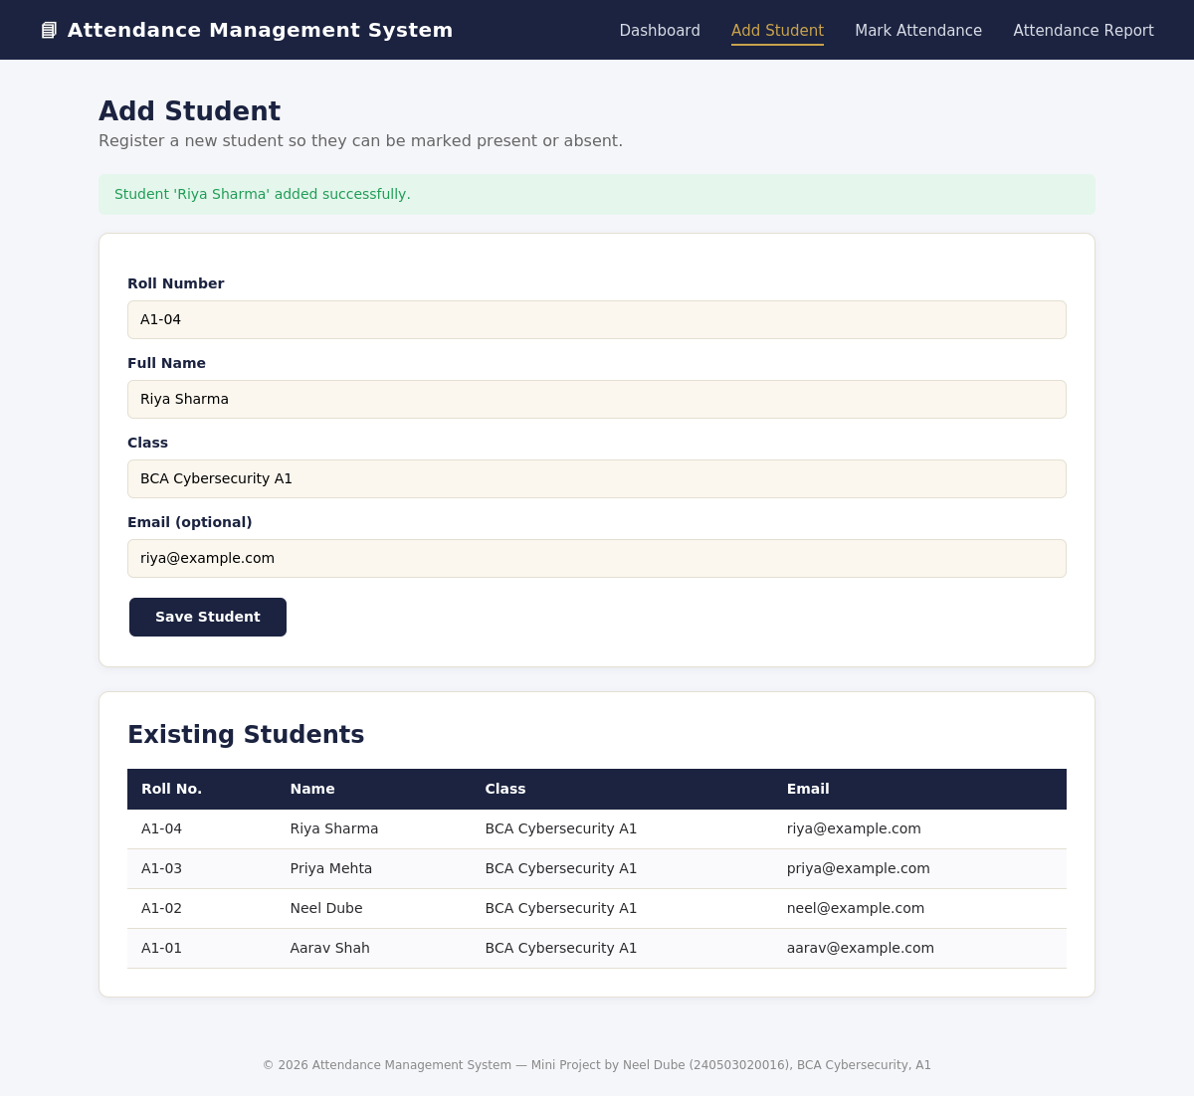
Figure 8.2 — Add Student form and student list

8.3 Mark Attendance
Selecting a date lists every student with a Present/Absent dropdown; saving updates the attendance table for that date in one action.
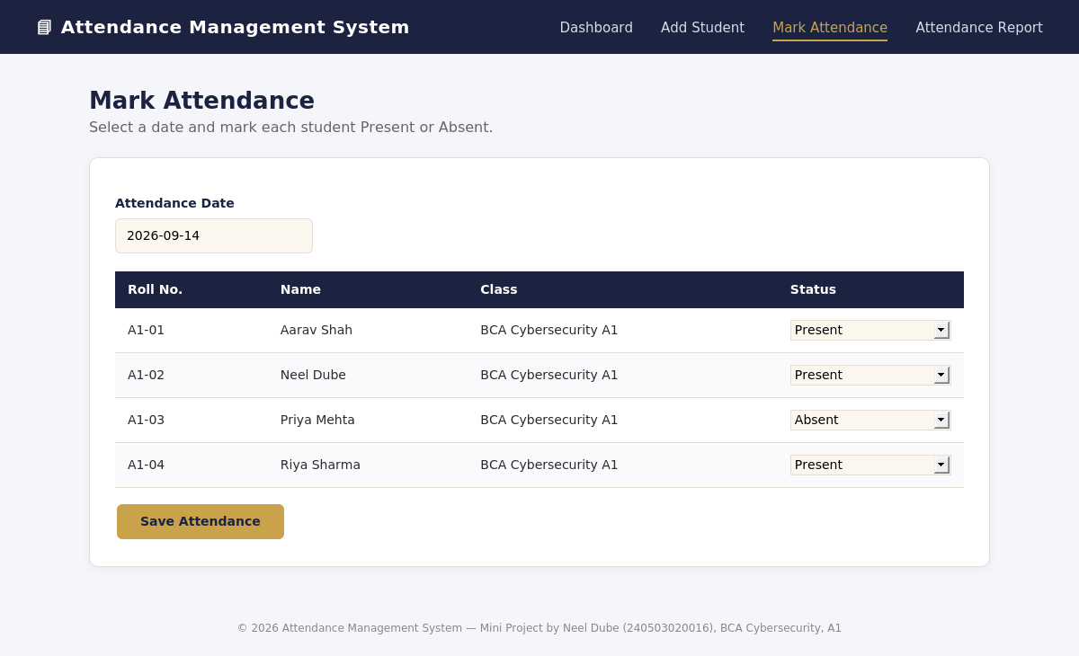
Figure 8.3 — Marking attendance for a selected date

8.4 Attendance Report
The report aggregates each student's attendance history into a percentage, with a progress bar and red/green badge indicating standing against the 75% threshold.
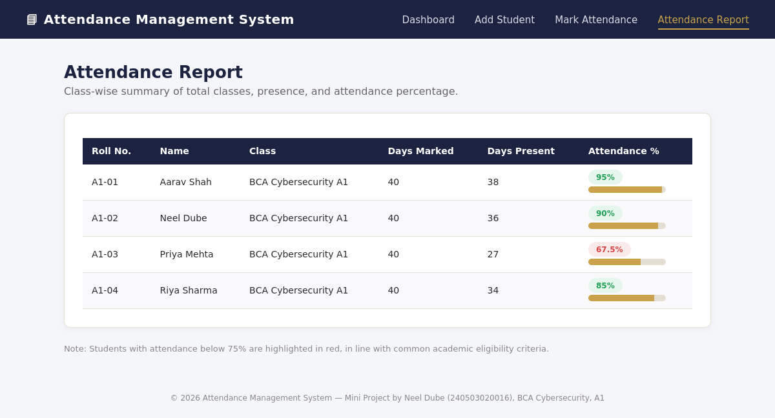
Figure 8.4 — Attendance report with computed percentages

9. Testing
Each module was tested manually against expected and edge-case inputs before the system was considered complete. Key test cases are summarized below.
Test Case | Input | Expected Result | Status
Add student with valid data | Roll no, name, class filled | Student inserted and shown in list | Pass
Add student with duplicate roll no. | Existing roll_no reused | Database rejects insert (UNIQUE constraint) | Pass
Mark attendance for new date | Date + status for each student | New attendance rows created | Pass
Re-mark attendance for same date | Same date, changed status | Existing rows updated, no duplicates | Pass
Generate report with no attendance | Student with 0 records | Percentage shown as 0%, no division error | Pass
Attendance below 75% | Student with low presence | Row flagged with red badge | Pass

10. Future Scope
▸ Role-based login so teachers, students, and admins see different views and permissions.
▸ Automated email or SMS alerts when a student's attendance drops below the eligibility threshold.
▸ Export of attendance reports to PDF or Excel for offline record-keeping.
▸ Class/subject-wise attendance instead of a single daily record, for institutions with multiple periods per day.
▸ A mobile-friendly or app-based interface for marking attendance directly from a classroom device.

11. Conclusion
The Attendance Management System demonstrates how a small set of well-defined features — adding students, marking attendance, generating reports, and calculating percentages — can replace an error-prone manual process with a reliable, easy-to-use web application. Built entirely on PHP and MySQL, the project required no specialized infrastructure while still covering core web-development concepts: relational database design, server-side form handling, prepared statements for security, and aggregate SQL queries for reporting. The result is a complete, working mini project that is both immediately usable and straightforward to extend with the future enhancements outlined above.

Appendix A: Full Source Code Listing
The complete source code is included with this submission as a separate PHP project folder. Full listings of each file are reproduced below for reference.

A.1 db_connect.php
<?php
/**
* db_connect.php
* Establishes a MySQLi connection used by every page in the project.
* Update the credentials below to match your local MySQL / XAMPP setup.
*/

$DB_HOST = "localhost";
$DB_USER = "root";
$DB_PASS = "";
$DB_NAME = "attendance_db";

$conn = new mysqli($DB_HOST, $DB_USER, $DB_PASS, $DB_NAME);

if ($conn->connect_error) {
die("Database connection failed: " . $conn->connect_error);
}
?>

A.2 index.php (Dashboard)
<?php
include 'db_connect.php';
include 'includes/header.php';

// Total students
$totalStudents = $conn->query("SELECT COUNT(*) AS c FROM students")->fetch_assoc()['c'];

// Today's attendance
$today = date("Y-m-d");
$presentToday = $conn->query("SELECT COUNT(*) AS c FROM attendance WHERE date_marked='$today' AND status='Present'")->fetch_assoc()['c'];
$absentToday = $conn->query("SELECT COUNT(*) AS c FROM attendance WHERE date_marked='$today' AND status='Absent'")->fetch_assoc()['c'];

// Overall average attendance percentage
$avgRow = $conn->query("
SELECT ROUND(SUM(status='Present')/COUNT(*)*100, 1) AS avg_pct
FROM attendance
")->fetch_assoc();
$avgPct = $avgRow['avg_pct'] !== null ? $avgRow['avg_pct'] : 0;
?>

<h1 class="page-title">Dashboard</h1>
<p class="page-sub">Overview of students and today's attendance at a glance.</p>

<div class="stat-grid">
<div class="stat-card">
<div class="num"><?= $totalStudents ?></div>
<div class="lbl">Total Students</div>
</div>
<div class="stat-card">
<div class="num"><?= $presentToday ?></div>
<div class="lbl">Present Today</div>
</div>
<div class="stat-card">
<div class="num"><?= $absentToday ?></div>
<div class="lbl">Absent Today</div>
</div>
<div class="stat-card">
<div class="num"><?= $avgPct ?>%</div>
<div class="lbl">Overall Attendance</div>
</div>
</div>

<div class="card">
<h2 style="color:var(--navy); margin-top:0;">Quick Actions</h2>
<a href="add_student.php" class="btn">+ Add Student</a>
<a href="mark_attendance.php" class="btn btn-gold">Mark Today's Attendance</a>
<a href="attendance_report.php" class="btn" style="background:#445070;">View Report</a>
</div>

<?php include 'includes/footer.php'; ?>

A.3 add_student.php
<?php
include 'db_connect.php';
include 'includes/header.php';

$message = "";

if ($_SERVER['REQUEST_METHOD'] === 'POST') {
$roll = trim($_POST['roll_no']);
$name = trim($_POST['full_name']);
$class = trim($_POST['class_name']);
$email = trim($_POST['email']);

$stmt = $conn->prepare("INSERT INTO students (roll_no, full_name, class_name, email) VALUES (?, ?, ?, ?)");
$stmt->bind_param("ssss", $roll, $name, $class, $email);

if ($stmt->execute()) {
$message = "Student '$name' added successfully.";
} else {
$message = "Error: " . $stmt->error;
}
$stmt->close();
}

$students = $conn->query("SELECT * FROM students ORDER BY student_id DESC");
?>

<h1 class="page-title">Add Student</h1>
<p class="page-sub">Register a new student so they can be marked present or absent.</p>

<?php if ($message): ?>
<div class="alert-success"><?= htmlspecialchars($message) ?></div>
<?php endif; ?>

<div class="card">
<form method="POST" action="add_student.php">
<label>Roll Number</label>
<input type="text" name="roll_no" placeholder="e.g. A1-04" required>

<label>Full Name</label>
<input type="text" name="full_name" placeholder="e.g. Riya Sharma" required>

<label>Class</label>
<input type="text" name="class_name" placeholder="e.g. BCA Cybersecurity A1" required>

<label>Email (optional)</label>
<input type="email" name="email" placeholder="student@example.com">

<button type="submit" class="btn">Save Student</button>
</form>
</div>

<div class="card">
<h2 style="color:var(--navy); margin-top:0;">Existing Students</h2>
<table>
<thead>
<tr><th>Roll No.</th><th>Name</th><th>Class</th><th>Email</th></tr>
</thead>
<tbody>
<?php while ($row = $students->fetch_assoc()): ?>
<tr>
<td><?= htmlspecialchars($row['roll_no']) ?></td>
<td><?= htmlspecialchars($row['full_name']) ?></td>
<td><?= htmlspecialchars($row['class_name']) ?></td>
<td><?= htmlspecialchars($row['email']) ?></td>
</tr>
<?php endwhile; ?>
</tbody>
</table>
</div>

<?php include 'includes/footer.php'; ?>

A.4 mark_attendance.php
<?php
include 'db_connect.php';
include 'includes/header.php';

$message = "";
$selectedDate = $_POST['date_marked'] ?? $_GET['date_marked'] ?? date("Y-m-d");

// Handle attendance submission
if ($_SERVER['REQUEST_METHOD'] === 'POST' && isset($_POST['submit_attendance'])) {
$date = $_POST['date_marked'];
$statuses = $_POST['status']; // array: student_id => Present/Absent

$stmt = $conn->prepare("
INSERT INTO attendance (student_id, date_marked, status)
VALUES (?, ?, ?)
ON DUPLICATE KEY UPDATE status = VALUES(status)
");

foreach ($statuses as $studentId => $status) {
$stmt->bind_param("iss", $studentId, $date, $status);
$stmt->execute();
}
$stmt->close();
$message = "Attendance for $date saved successfully.";
}

// Fetch students with today's/selected date's existing status (if any)
$students = $conn->query("
SELECT s.student_id, s.roll_no, s.full_name, s.class_name,
a.status AS current_status
FROM students s
LEFT JOIN attendance a
ON a.student_id = s.student_id AND a.date_marked = '$selectedDate'
ORDER BY s.roll_no
");
?>

<h1 class="page-title">Mark Attendance</h1>
<p class="page-sub">Select a date and mark each student Present or Absent.</p>

<?php if ($message): ?>
<div class="alert-success"><?= htmlspecialchars($message) ?></div>
<?php endif; ?>

<div class="card">
<form method="GET" action="mark_attendance.php" style="margin-bottom:10px;">
<label>Attendance Date</label>
<input type="date" name="date_marked" value="<?= htmlspecialchars($selectedDate) ?>" onchange="this.form.submit()">
</form>

<form method="POST" action="mark_attendance.php">
<input type="hidden" name="date_marked" value="<?= htmlspecialchars($selectedDate) ?>">
<table>
<thead>
<tr><th>Roll No.</th><th>Name</th><th>Class</th><th>Status</th></tr>
</thead>
<tbody>
<?php while ($row = $students->fetch_assoc()):
$isPresent = ($row['current_status'] ?? 'Present') === 'Present';
?>
<tr>
<td><?= htmlspecialchars($row['roll_no']) ?></td>
<td><?= htmlspecialchars($row['full_name']) ?></td>
<td><?= htmlspecialchars($row['class_name']) ?></td>
<td>
<select name="status[<?= $row['student_id'] ?>]">
<option value="Present" <?= $isPresent ? 'selected' : '' ?>>Present</option>
<option value="Absent" <?= !$isPresent ? 'selected' : '' ?>>Absent</option>
</select>
</td>
</tr>
<?php endwhile; ?>
</tbody>
</table>
<button type="submit" name="submit_attendance" class="btn btn-gold">Save Attendance</button>
</form>
</div>

<?php include 'includes/footer.php'; ?>

A.5 attendance_report.php
<?php
include 'db_connect.php';
include 'includes/header.php';

// Calculate attendance percentage per student
$query = "
SELECT
s.student_id,
s.roll_no,
s.full_name,
s.class_name,
COUNT(a.attendance_id) AS total_marked,
SUM(a.status = 'Present') AS total_present,
ROUND(
IFNULL(SUM(a.status = 'Present') / NULLIF(COUNT(a.attendance_id), 0) * 100, 0), 1
) AS attendance_pct
FROM students s
LEFT JOIN attendance a ON a.student_id = s.student_id
GROUP BY s.student_id
ORDER BY s.roll_no
";
$result = $conn->query($query);
?>

<h1 class="page-title">Attendance Report</h1>
<p class="page-sub">Class-wise summary of total classes, presence, and attendance percentage.</p>

<div class="card">
<table>
<thead>
<tr>
<th>Roll No.</th>
<th>Name</th>
<th>Class</th>
<th>Days Marked</th>
<th>Days Present</th>
<th>Attendance %</th>
</tr>
</thead>
<tbody>
<?php while ($row = $result->fetch_assoc()):
$pct = (float) $row['attendance_pct'];
$badgeClass = $pct >= 75 ? 'badge-present' : 'badge-absent';
?>
<tr>
<td><?= htmlspecialchars($row['roll_no']) ?></td>
<td><?= htmlspecialchars($row['full_name']) ?></td>
<td><?= htmlspecialchars($row['class_name']) ?></td>
<td><?= $row['total_marked'] ?></td>
<td><?= $row['total_present'] ?></td>
<td>
<span class="badge <?= $badgeClass ?>"><?= $pct ?>%</span>
<div class="pct-bar-track" style="margin-top:6px;">
<div class="pct-bar-fill" style="width: <?= $pct ?>%;"></div>
</div>
</td>
</tr>
<?php endwhile; ?>
</tbody>
</table>
</div>

<p style="font-size:13px; color:#888;">
Note: Students with attendance below 75% are highlighted in red, in line with common academic eligibility criteria.
</p>

<?php include 'includes/footer.php'; ?>

A.6 schema.sql
-- =========================================================
-- Attendance Management System - Database Schema
-- Author : Neel Dube (240503020016)
-- =========================================================

CREATE DATABASE IF NOT EXISTS attendance_db;
USE attendance_db;

-- ---------------------------------------------------------
-- Table: students
-- Stores basic details of every enrolled student
-- ---------------------------------------------------------
CREATE TABLE IF NOT EXISTS students (
student_id INT AUTO_INCREMENT PRIMARY KEY,
roll_no VARCHAR(20) NOT NULL UNIQUE,
full_name VARCHAR(100) NOT NULL,
class_name VARCHAR(50) NOT NULL,
email VARCHAR(100),
created_at TIMESTAMP DEFAULT CURRENT_TIMESTAMP
);

-- ---------------------------------------------------------
-- Table: attendance
-- Stores one row per student per date with status
-- ---------------------------------------------------------
CREATE TABLE IF NOT EXISTS attendance (
attendance_id INT AUTO_INCREMENT PRIMARY KEY,
student_id INT NOT NULL,
date_marked DATE NOT NULL,
status ENUM('Present', 'Absent') NOT NULL,
created_at TIMESTAMP DEFAULT CURRENT_TIMESTAMP,
FOREIGN KEY (student_id) REFERENCES students(student_id) ON DELETE CASCADE,
UNIQUE KEY unique_attendance (student_id, date_marked)
);

-- Sample seed data (optional, for testing)
INSERT INTO students (roll_no, full_name, class_name, email) VALUES
('A1-01', 'Aarav Shah', 'BCA Cybersecurity A1', 'aarav@example.com'),
('A1-02', 'Neel Dube', 'BCA Cybersecurity A1', 'neel@example.com'),
('A1-03', 'Priya Mehta', 'BCA Cybersecurity A1', 'priya@example.com');

